Create Quiz Test Requirements
Input Space Partitions

1. Input variables:
5 input boxes: Name, lenght (in minutes, open date, due date, number of submissions(NOS) )
2 buttons: Create questions, cancel
2. Definition of charasteristics of input variables:
char 1: name is empty or not
char 2: lenght and NOS are numbers or not
char 3: lenght and NOD compare to 0
char 4: open and due area dates
char 5: form button is clicked
3. Partitions:
char 1: [empty, not empty]
char 2: [number, not number]
char 3: [neg, 0, pos]
char 4: [date, not date]
char 5: [create questions, cancel]
4. Completeness and disjointness:
It is complete but not disjoint
5. Values:
char 1: ["", "a" ]
char 2: [1,a]
char 3: [-1, 0, 1]
char 4: [11/14/2018 00:00, 12]
char 5: [create questions, cancel]
6. Test requirements that satifies Base Choice coverage:
Base tr:
tr 1: ["a", 1, 1, 11/14/2018 00:00, create questions]
Base coverage:
tr 2: ["a", 1, 1, 11/14/2018 00:00, cancel]
tr 3: ["a", 1, 1, 12, create questions]
tr 4: ["a", 1, 0, 11/14/2018 00:00, create questions]
tr 5: ["a", 1, -1, 11/14/2018 00:00, create questions]
tr 6: ["a", a, 1, 11/14/2018 00:00, create questions]
tr 7: ["", 1, 1, 11/14/2018 00:00, create questions]
Infeasible tests:
tr 4
tr 5
tr 6
Fix infeasible test:
tr 4: ["a", 0, 0, 11/14/2018 00:00, create questions]
tr 5: ["a", -1, -1, 11/14/2018 00:00, create questions]
tr 6: ["a", a, a, 11/14/2018 00:00, create questions]
7. Test set:
tc 1: a, 1, 11/14/2018 00:00, 11/14/2018 00:00, 1, create questions (base)
Expected output: next page (create questions)

tc 2: a, 1, 11/14/2018 00:00, 11/14/2018 00:00, 1, cancel
Expected output: stay on current page (create quiz)

tc 3: a, 1, 12, 12, 1, create questions (base)
Expected output: error message ("enter valid date")

tc 4: a, 0, 11/14/2018 00:00, 11/14/2018 00:00, 0, create questions (base)
Expected output: unknown, perhaps invalid input message

tc 5: a, -1, 11/14/2018 00:00, 11/14/2018 00:00, -1, create questions (base)
Expected output: error message ("enter valid number")

tc 6: a, a, 11/14/2018 00:00, 11/14/2018 00:00, a, create questions (base)
Expected output: error message ("enter valid number")

tc 7: "", a, 11/14/2018 00:00, 11/14/2018 00:00, a, create questions (base)
Expected output: error message ("enter valid number")

8. Additional tests
An additional test was created to make sure that the correct page shows up with the given url.

Test Results:

The base case and test case 2 pass. In other words if the input is valid then the page displays expected behavior.

Conversely, test cases 3, 4, 5, 6, and 7 fail because the page does not meet the requirements for invalid input (see fig. CQ1). In other words, if the input is invalid the page doesn't display expected behavior. Developers must be notified to update page behavior to pass tests.

To ensure tests are working properly, tests were changed temporally to accept actual output as expected result. After this change all tests passed (see fig. CQ2), so test harness is working properly, and problems lie on the page's code.

Fig. CQ1: Some tests failing because page doesn't meet requirements
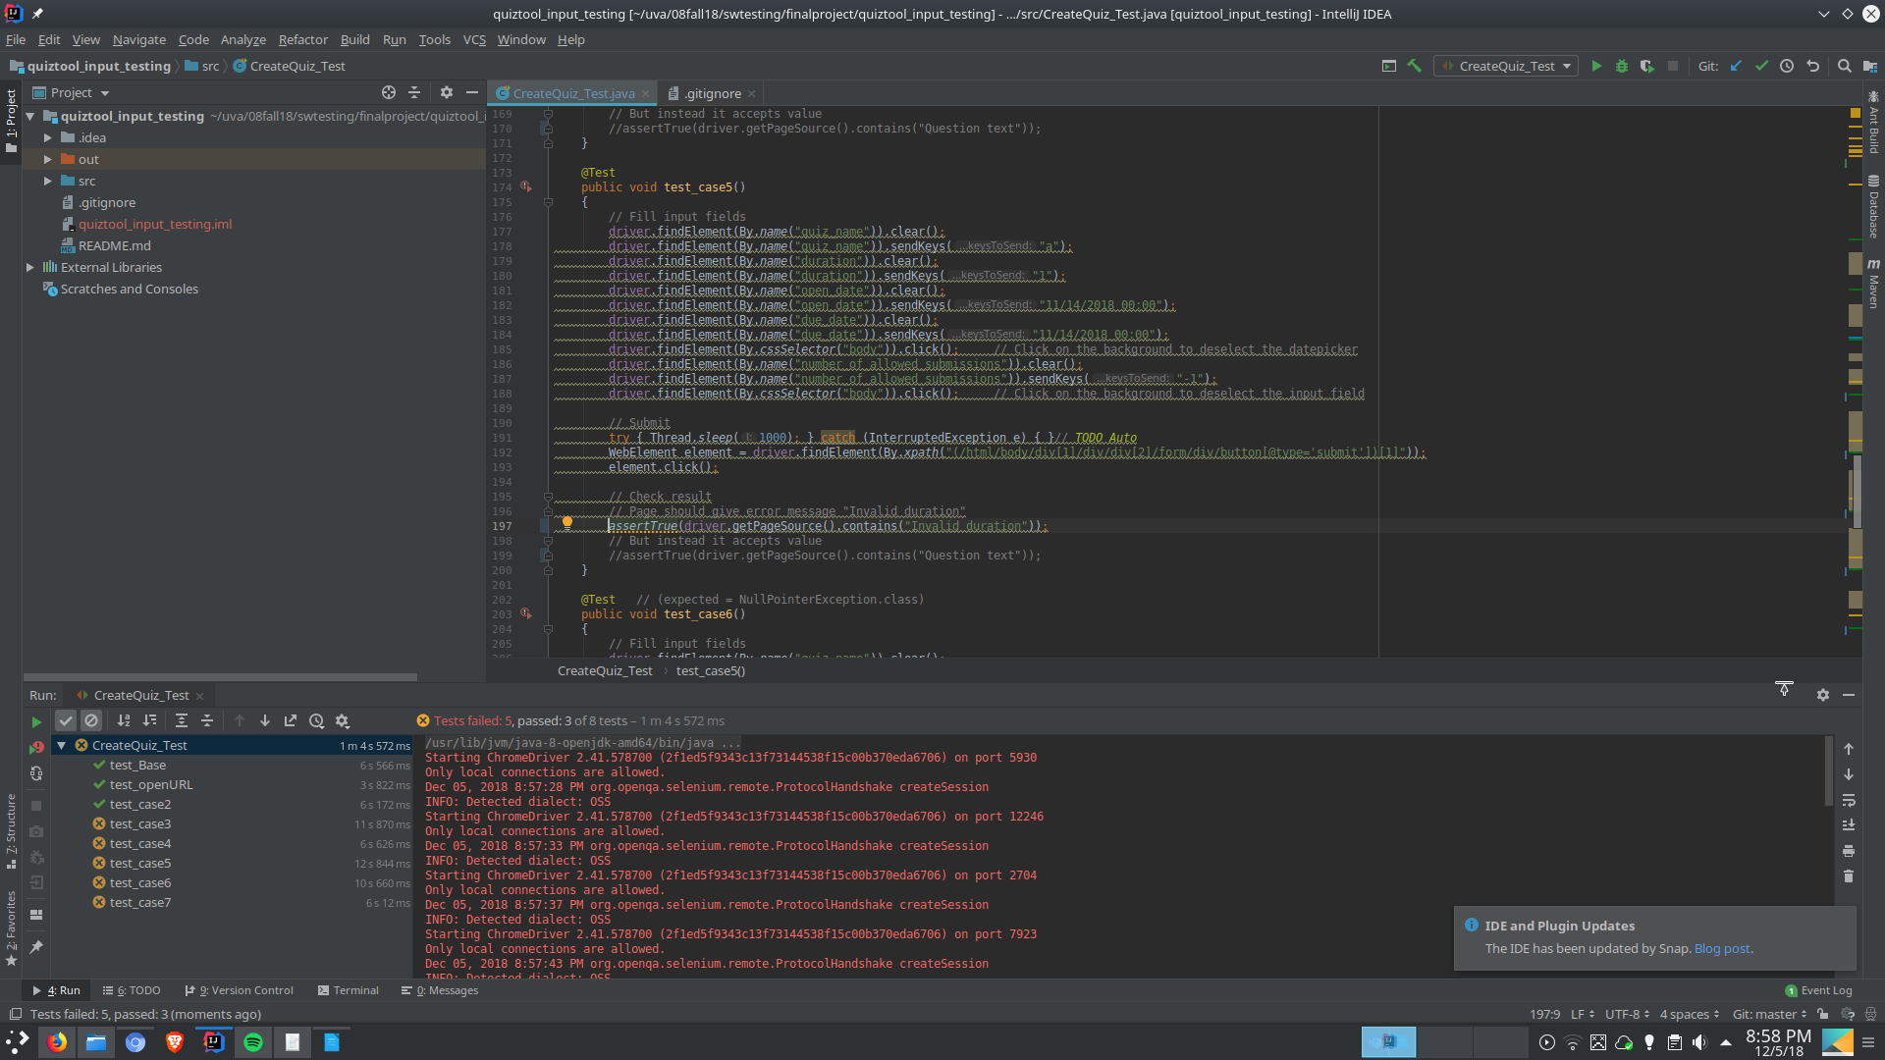

Fig. CQ2: All test passing to ensure test harness is working properly
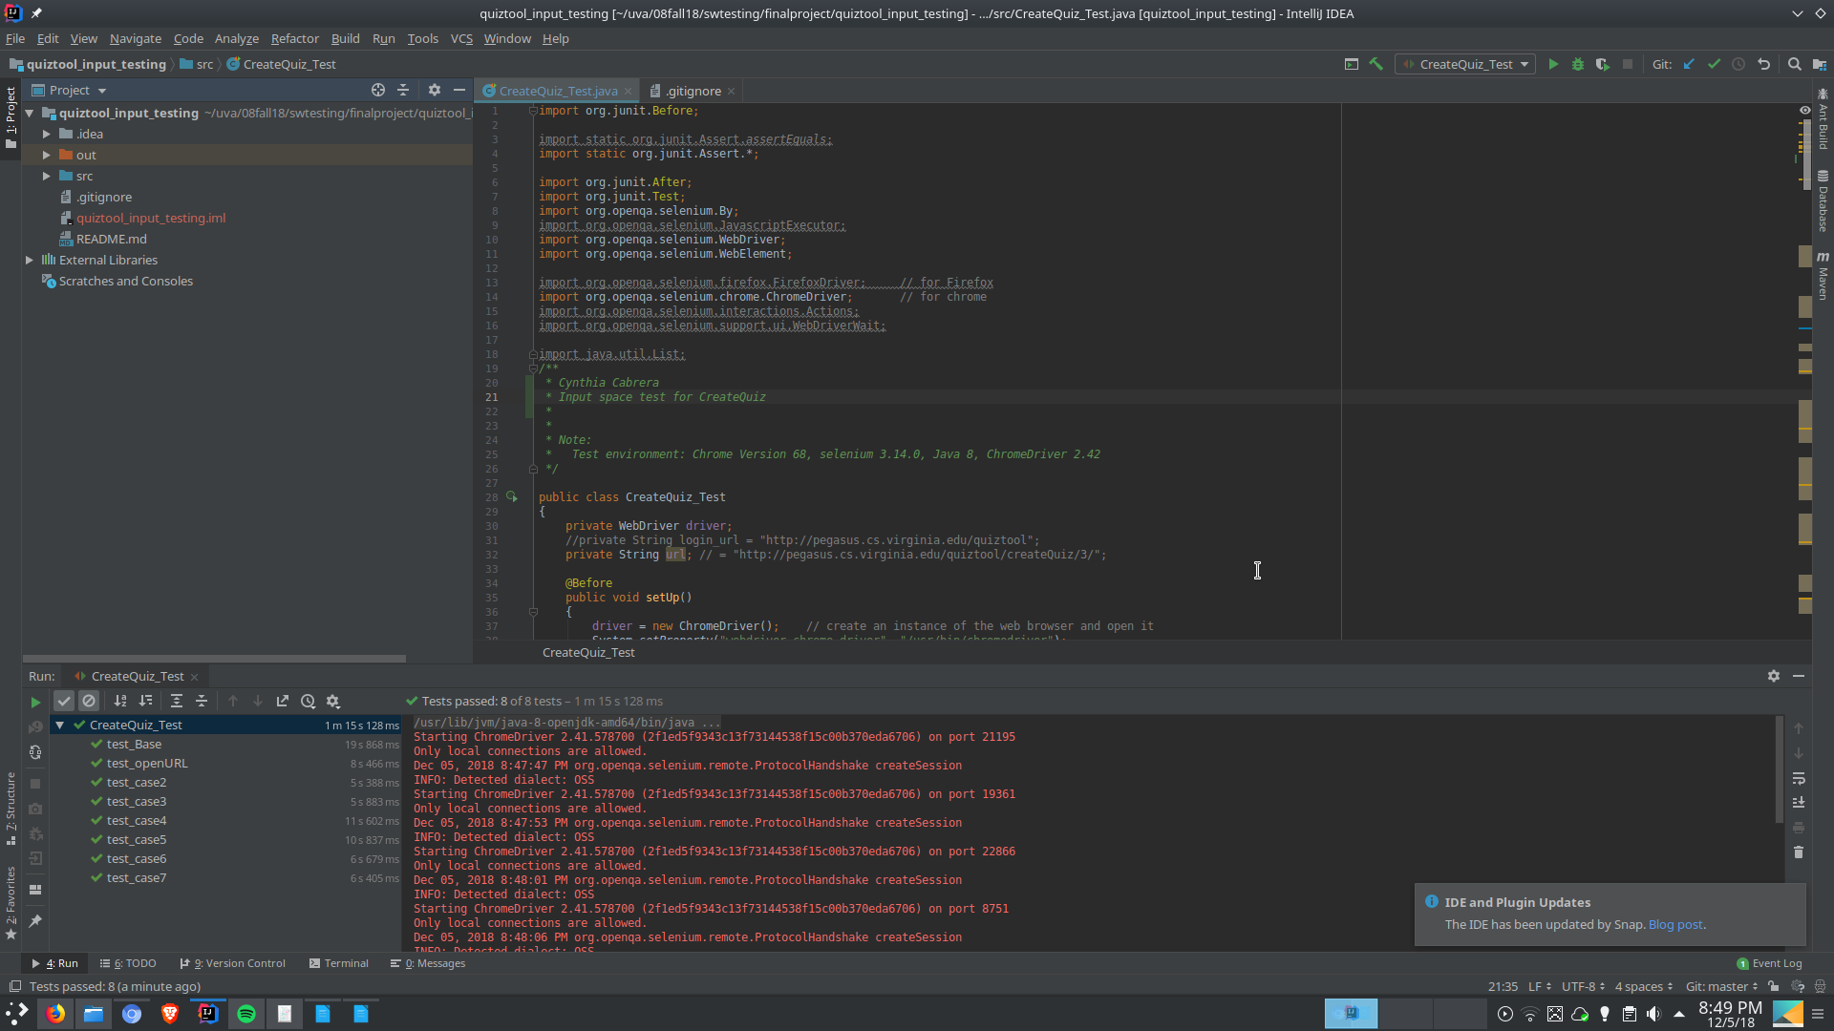

Automated Tests on Selenium

import org.junit.Before;
import static org.junit.Assert.assertEquals;
import static org.junit.Assert.*;
import org.junit.After;
import org.junit.Test;
import org.openqa.selenium.By;
import org.openqa.selenium.JavascriptExecutor;
import org.openqa.selenium.WebDriver;
import org.openqa.selenium.WebElement;
import org.openqa.selenium.firefox.FirefoxDriver; // for Firefox
import org.openqa.selenium.chrome.ChromeDriver; // for chrome
import org.openqa.selenium.interactions.Actions;
import org.openqa.selenium.support.ui.WebDriverWait;
import java.util.List;
/**
* Cynthia Cabrera
* Input space test for CreateQuiz
*
*
* Note:
* Test environment: Chrome Version 68, selenium 3.14.0, Java 8, ChromeDriver 2.42
*/
public class CreateQuiz_Test
{
private WebDriver driver;
//private String login_url = "http://pegasus.cs.virginia.edu/quiztool";
private String url; // = "http://pegasus.cs.virginia.edu/quiztool/createQuiz/3/";
@Before
public void setUp()
{
driver = new ChromeDriver(); // create an instance of the web browser and open it
System.setProperty("webdriver.chrome.driver", "/usr/bin/chromedriver");
//Login into quiztool app
url = "http://pegasus.cs.virginia.edu/quiztool/login";
driver.get(url); // open the given url
driver.findElement(By.name("username")).sendKeys("professorM");
driver.findElement(By.name("password")).sendKeys("swtesting1");
WebElement element = driver.findElement(By.xpath("(/html/body/div/div/form/div/button[@type='submit'])[1]"));
element.click();
// Go to createQuiz
url = "http://pegasus.cs.virginia.edu/quiztool/createQuiz/1/";
driver.get(url); // open the given url
}
@After
public void teardown()
{
driver.quit(); // close the browser
}
@Test
public void test_openURL()
{
assertTrue(driver.getPageSource().contains("Create a Quiz")); // check if we are on the right page
}
@Test
public void test_Base() // test case #1
{
// Fill input fields
driver.findElement(By.name("quiz_name")).clear();
driver.findElement(By.name("quiz_name")).sendKeys("a");
driver.findElement(By.name("duration")).clear();
driver.findElement(By.name("duration")).sendKeys("1");
driver.findElement(By.name("open_date")).clear();
driver.findElement(By.name("open_date")).sendKeys("11/14/2018 00:00");
driver.findElement(By.name("due_date")).clear();
driver.findElement(By.name("due_date")).sendKeys("11/14/2018 00:00");
driver.findElement(By.cssSelector("body")).click(); // Click on the background to deselect the datepicker
driver.findElement(By.name("number_of_allowed_submissions")).clear();
driver.findElement(By.name("number_of_allowed_submissions")).sendKeys("1");
driver.findElement(By.cssSelector("body")).click(); // Click on the background to deselect the input field
// Submit
WebElement element = driver.findElement(By.xpath("(/html/body/div[1]/div/div[2]/form/div/button[@type='submit'])[1]"));
element.click();
// Check result
assertTrue(driver.getPageSource().contains("Question text"));
}
@Test
public void test_case2()
{
// Fill input fields
driver.findElement(By.name("quiz_name")).clear();
driver.findElement(By.name("quiz_name")).sendKeys("a");
driver.findElement(By.name("duration")).clear();
driver.findElement(By.name("duration")).sendKeys("1");
driver.findElement(By.name("open_date")).clear();
driver.findElement(By.name("open_date")).sendKeys("11/14/2018 00:00");
driver.findElement(By.name("due_date")).clear();
driver.findElement(By.name("due_date")).sendKeys("11/14/2018 00:00");
driver.findElement(By.cssSelector("body")).click(); // Click on the background to deselect the datepicker
driver.findElement(By.name("number_of_allowed_submissions")).clear();
driver.findElement(By.name("number_of_allowed_submissions")).sendKeys("1");
driver.findElement(By.cssSelector("body")).click(); // Click on the background to deselect the input field
driver.findElement(By.linkText("Cancel")).click();
//element.click();
//try { Thread.sleep(1000); } catch (InterruptedException e) { }// TODO Auto
assertTrue(driver.getPageSource().contains("CS 4501"));
}
@Test
public void test_case3()
{
// Fill input fields
driver.findElement(By.name("quiz_name")).clear();
driver.findElement(By.name("quiz_name")).sendKeys("a");
driver.findElement(By.name("duration")).clear();
driver.findElement(By.name("duration")).sendKeys("1");
driver.findElement(By.name("open_date")).clear();
driver.findElement(By.name("open_date")).sendKeys("12");
driver.findElement(By.name("due_date")).clear();
driver.findElement(By.name("due_date")).sendKeys("12");
driver.findElement(By.cssSelector("body")).click(); // Click on the background to deselect the datepicker
driver.findElement(By.name("number_of_allowed_submissions")).clear();
driver.findElement(By.name("number_of_allowed_submissions")).sendKeys("1");
driver.findElement(By.cssSelector("body")).click(); // Click on the background to deselect the input field
// Click cancel
try { Thread.sleep(1000); } catch (InterruptedException e) { }// TODO Auto
WebElement element = driver.findElement(By.xpath("(/html/body/div[1]/div/div[2]/form/div/button[@type='submit'])[1]"));
element.click();
// Check result
// Page should give error message "Invalid date"
assertTrue(driver.getPageSource().contains("Invalid date"));
// But instead breaks down
//assertTrue(driver.getPageSource().contains("TypeError"));
}
@Test
public void test_case4()
{
// Fill input fields
driver.findElement(By.name("quiz_name")).clear();
driver.findElement(By.name("quiz_name")).sendKeys("a");
driver.findElement(By.name("duration")).clear();
driver.findElement(By.name("duration")).sendKeys("1");
driver.findElement(By.name("open_date")).clear();
driver.findElement(By.name("open_date")).sendKeys("11/14/2018 00:00");
driver.findElement(By.name("due_date")).clear();
driver.findElement(By.name("due_date")).sendKeys("11/14/2018 00:00");
driver.findElement(By.cssSelector("body")).click(); // Click on the background to deselect the datepicker
driver.findElement(By.name("number_of_allowed_submissions")).clear();
driver.findElement(By.name("number_of_allowed_submissions")).sendKeys("0");
driver.findElement(By.cssSelector("body")).click(); // Click on the background to deselect the input field
// Submit
try { Thread.sleep(1000); } catch (InterruptedException e) { }// TODO Auto
WebElement element = driver.findElement(By.xpath("(/html/body/div[1]/div/div[2]/form/div/button[@type='submit'])[1]"));
element.click();
// Check result
// Page should give error message "Invalid duration"
assertTrue(driver.getPageSource().contains("Invalid duration"));
// But instead it accepts value
//assertTrue(driver.getPageSource().contains("Question text"));
}
@Test
public void test_case5()
{
// Fill input fields
driver.findElement(By.name("quiz_name")).clear();
driver.findElement(By.name("quiz_name")).sendKeys("a");
driver.findElement(By.name("duration")).clear();
driver.findElement(By.name("duration")).sendKeys("1");
driver.findElement(By.name("open_date")).clear();
driver.findElement(By.name("open_date")).sendKeys("11/14/2018 00:00");
driver.findElement(By.name("due_date")).clear();
driver.findElement(By.name("due_date")).sendKeys("11/14/2018 00:00");
driver.findElement(By.cssSelector("body")).click(); // Click on the background to deselect the datepicker
driver.findElement(By.name("number_of_allowed_submissions")).clear();
driver.findElement(By.name("number_of_allowed_submissions")).sendKeys("-1");
driver.findElement(By.cssSelector("body")).click(); // Click on the background to deselect the input field
// Submit
try { Thread.sleep(1000); } catch (InterruptedException e) { }// TODO Auto
WebElement element = driver.findElement(By.xpath("(/html/body/div[1]/div/div[2]/form/div/button[@type='submit'])[1]"));
element.click();
// Check result
// Page should give error message "Invalid duration"
assertTrue(driver.getPageSource().contains("Invalid duration"));
// But instead it accepts value
//assertTrue(driver.getPageSource().contains("Question text"));
}
@Test // (expected = NullPointerException.class)
public void test_case6()
{
// Fill input fields
driver.findElement(By.name("quiz_name")).clear();
driver.findElement(By.name("quiz_name")).sendKeys("a");
driver.findElement(By.name("duration")).clear();
driver.findElement(By.name("duration")).sendKeys("1");
driver.findElement(By.name("open_date")).clear();
driver.findElement(By.name("open_date")).sendKeys("11/14/2018 00:00");
driver.findElement(By.name("due_date")).clear();
driver.findElement(By.name("due_date")).sendKeys("11/14/2018 00:00");
driver.findElement(By.cssSelector("body")).click(); // Click on the background to deselect the datepicker
driver.findElement(By.name("number_of_allowed_submissions")).clear();
driver.findElement(By.name("number_of_allowed_submissions")).sendKeys("a");
driver.findElement(By.cssSelector("body")).click(); // Click on the background to deselect the input field
// Submit
try { Thread.sleep(1000); } catch (InterruptedException e) { }// TODO Auto
WebElement element = driver.findElement(By.xpath("(/html/body/div[1]/div/div[2]/form/div/button[@type='submit'])[1]"));
element.click();
// Check result
// Page should give error message "Invalid duration"
assertTrue(driver.getPageSource().contains("Invalid duration"));
// But instead it doesn't give error message but it won't submit which is a good behavior
//assertTrue(driver.getPageSource().contains("Create a Quiz"));
}
@Test // (expected = NullPointerException.class)
public void test_case7()
{
// Fill input fields
driver.findElement(By.name("quiz_name")).clear();
driver.findElement(By.name("quiz_name")).sendKeys("");
driver.findElement(By.name("duration")).clear();
driver.findElement(By.name("duration")).sendKeys("1");
driver.findElement(By.name("open_date")).clear();
driver.findElement(By.name("open_date")).sendKeys("11/14/2018 00:00");
driver.findElement(By.name("due_date")).clear();
driver.findElement(By.name("due_date")).sendKeys("11/14/2018 00:00");
driver.findElement(By.cssSelector("body")).click(); // Click on the background to deselect the datepicker
driver.findElement(By.name("number_of_allowed_submissions")).clear();
driver.findElement(By.name("number_of_allowed_submissions")).sendKeys("1");
driver.findElement(By.cssSelector("body")).click(); // Click on the background to deselect the input field
// Submit
try { Thread.sleep(1000); } catch (InterruptedException e) { }// TODO Auto
WebElement element = driver.findElement(By.xpath("(/html/body/div[1]/div/div[2]/form/div/button[@type='submit'])[1]"));
element.click();
// Check result
// Page should give error message "Please fill out this field."
assertTrue(driver.getPageSource().contains("Please fill out this field"));
// But instead it accepts value
//assertTrue(driver.getPageSource().contains("Create a Quiz"));
}
}

